**4.2 Meiosis**

Is a relatively rare type of cell division that produces haploid gamete cells (sperm, pollen nuclei, ovules and eggs)

Meiosis can be view as two consecutive rounds of cell division:

1) Meiosis 1 separates the homologous pairs of chromosomes  
2) Meiosis 2 separates the sister chromatids.

**4.2.1 State that meiosis is a reduction division of a diploid nucleus to form haploid nuclei.(1)**

State means to give a specific name, value or other brief answer without explanation or calculation.

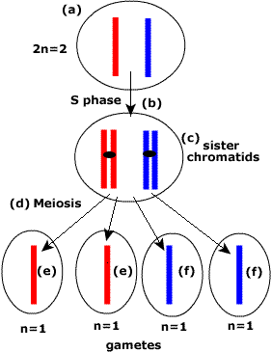Meiosis is a reduction division of a diploid nucleus(2n) to form a haploid nucleus (n).

For clarity the nuclear membrane has been omitted from the diagram.

1. The cell is in G1 of the interphase and has a total of 2 chromosomes, 2n=2.
2. The S phase of the interphase is DNA replication.
3. In G2 of the interphase the cell has two daughter chromatids per chromosome, the cell mass of DNA has doubled.
4. Meiosis occurs in a series of phases similar to mitosis ut with significant differences.
5. The diploid cell has divided to form haploid gamete cells (n=1).
6. The homologous pair of chromosomes has been separated (red from blue).

One diploid cell which undergoes meiosis produces four haploid gametic cells.

**4.2.2 Define homologous chromosomes. (1)**

Define means to give the precise meaning of a word, phrase or physical quantity.  
  
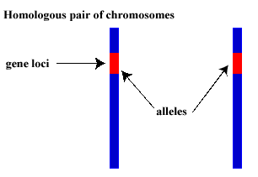

* Homologous chromosomes form pairs within the nucleus and during cell division.
* The name suggest that both members of the pair share certain structural characteristics.
* They are the same length of chromosomes.
* They have the same shape of chromosomes.
* They carry the same genes in the same gene loci.
* The forms of the gene found on the homologous pairs are the alleles of the gene that an individual may posses. Note that for every gene there are normally two alleles in the individual.

**4.2.3 Outline the process of meiosis, including pairing of homologous chromosomes and crossing over, followed by two divisions, which results in four haploid cells. (2)**

Outline means to give a brief account or summary.

Meiosis is a form of cell division that produces gametes. It takes place in the reproductive organs and shows variation in how long the process occurs. Although meiosis can produce millions of gametes in a short period of time in comparison to mitosis in the body it is relatively rare.

The stages of meiosis are shown below but begins with some diagrams about Interphase as a reminder. In the diagrams homologous pairs are shown in different colours ((red with blue), (purple with green)). The organism shown is an animal cell with a diploid number (2n)= 4. Therefore we expect to see four gametes each with a haploid number (n) =2.

**Meiosis I:**This is the first of two sets of divisions. In meiosis one the prophase, metaphase, anaphase and telophase will divide the cell into two and separate the homologous pairs. This is perhaps the most significant step in terms of genetics.

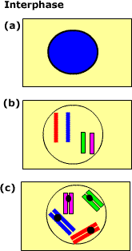**(a)** The nuclear membrane is intact and the chromosomes inside cannot be seen. At this stage the chromosomes are not greatly coiled or condensed which allows genes to be expressed. Each DNA molecule is about 1.8m long but still wound sufficiently such that it can be contained inside a 10um nucleus.

**(b)**In the G1 stage of the Interphase each chromosome is a single DNA molecule (+histones). Here we can see (although in-reality you cannot since the nucleus is intact) that there are four chromosomes and the diploid number of the cell is 2n=4. Red and blue are a homologous pair as are green and purple.

**(c)**In S1 of the interphase the DNA molecules replicate. Each copy (sister chromatids) are held together at the centromere (black dot). The cell is now preparing for the meiotic division in which:  
Chromosome number will be halved and the Homologous chromosomes will be separated

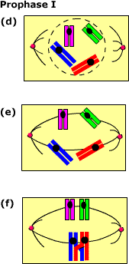 **(d)** Early prophase, the nuclear membrane is breaking down.

The spindle of microtubules is forming from opposite ends of the cell.

Centrioles organise the spindle construction at the poles of the cell.

**(e)**The pairs of sister chromatids attach to the spindle microtubules at the centromere.

The DNA is condensing by super coiling, this will reach it peak in the metaphase.

**(f)** The pairs of chromatids will move up and down the between the poles but gradually move towards the equatorial plate (centre) of the cell.

The nucleus has now disappeared and the chromosomes are dense enough to be seen with a light microscope. Note that the red and blue homologous pair are 'crossing over' , see metaphase for details.

Prophase is the longest of the meiotic phases of cell division. In humans the process of meiosis in the testes can take up to a month form the diploid cell to the mature sperms cell. In human females the process begins as a foetus whilst still in the uterus but does not complete until the instance of fertilisation many years later.

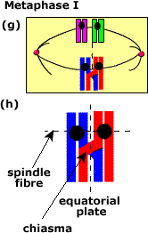

**(g)**The metaphase is marked by **all**pairs of sister chromatids aligned on the equator.

The chromosomes are at their most condensed and therefore most visible at the metaphase.

**(h)** **Cross-over.** Notice that the chromosome of one homologous chromosome is exchanging with the chromosome of the parallel non-sister chromosome.

Cross-over is the exchange of genetic material between non-sister chromatids during Prophase I but is most readily seen during the metaphase.

The point at which the chromosomes exchange genetic information is called the **chiasma.** This may occur many times along a chromosome and not just once as shown in the diagram.

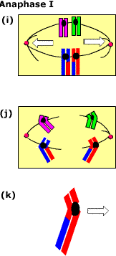  
**(i)** Early anaphase with the homologous pairs are aligned together on the equatorial plate of the cell

The spindle microtubules contract and pull the homologous pairs (alleles) apart.

The homologous pairs separate one to either pole. This is the case with all homologous pairs.

**(j)**Late anaphase the pairs of chromatids are moving to the poles.

Notice that there has been an exchange of genetic material on the 'arm' of the red and blue homologous pair.

New combinations of genes are not found on the same chromosome.

**(K)** Illustrates how to identify anaphase by the 'arrow' shape make by the pair of sister chromatids points towards the poles.

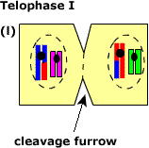**(l)**chromosomes are now in two sets at opposite ends of the cell.

Each set contains one from each of the homologous pairs.

In some species a nuclear membrane may form, in others there is a progression straight into Prophase II.

The cell membrane 'pinches' towards the centre in a 'cleavage furrow' the membrane will fuse at a central point and the cell will have divided in half.

This marks the end of meiosis one (reduction division) in which the homologous pairs have been separated.

**Meiosis II**: involves the separation of the sister chromatids and looks very like mitosis.

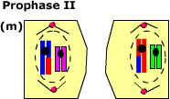

**(m)** The nuclear membrane breaks down if present.

Spindles reform ( shown here in the vertical plane only to distinguish from the diagrams above).

Centrioles begin the organisation of the spindle microtubules.

Pairs of sister chromatids will attach one to each spindle microtubule set.

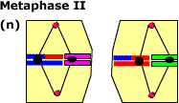

**(n)** All Pairs of sister chromatids aligned on the equatorial plate of the cell.

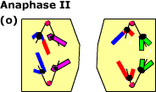

**(o)** The spindle fibres contract and the pairs of sister chromatids separate.

Each pole receives one of the chromosomes ( one chromatid).

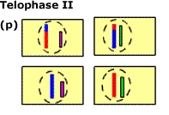**(p)**Nuclear membranes form around each of the **tetrad**of haploid game cells.

Notice that each cell contains two chromosomes n=2 (haploid).

Notice that the homologous pairs are separated (no red with blue, no purple with green)

There are some unusual chromosomes with exchanged genetic material due to cross-over.

[top](http://click4biology.info/c4b/4/gene4.2.htm#top)

**Non-syllabus information:**

**Fertilisation = n + n = 2n**

Two cells (from meiosis) one the female (egg) the other the male sperm (n) will join together their sets of chromosomes to form a new complete diploid set, this is called fertilisation.

The diploid offspring are genetically unique and show differences to other individuals both their parents, siblings and others in the population. The members of a population show differences (variation) for a given characteristic. This is the basis of one of the remarkable contributions of Charles Darwin to biology,*population thinking* , which is to say that a population shows variation. Of course Darwin new little of the details of meiosis.

**4.2.4 Explain that non-disjunction can lead to changes in chromosome number, illustrated by reference to Down  
syndrome (trisomy 21). Objective level (3)**

Explain means to give a detailed account of causes, reasons or mechanisms.

Non-disjunction is an error in meiosis produce cells with 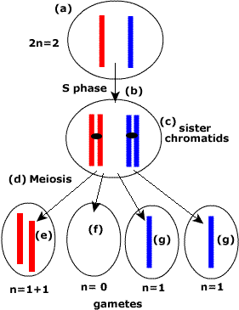unusual combinations of chromosomes.

(a) This is the diploid parental cell (2n=2)

(b) S-phase involves DNA replication during the interphase.

(c) Pairs of sister chromatids are formed during the interphase

(d) meiosis should separate; i) Homologous pairs ii) sister chromatids, so that each cell contains one chromosome (in this example).

(e) Has an extra red chromosome so that sister chromatids have failed to separate during meiosis II. This games has one extra chromosomes

(f) This gamete has one less chromosome that it should have (none in this case).

(g) These gametes are normal

Non-disjunction can also occur during meiosis I in which case all the tetrad are affected.

Example: **Downs Syndrome**

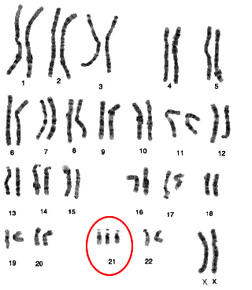Trisomy 21: An individual with Down's syndrome has three copies of chromosome 21.

During meiosis the sister chromatids have not been separated (non-disjunction) so that the gamete has had 24 chromosomes (23 + i extra chromosome number 21).

At fertilisation when the chromosomes form new homologous pairs the 21stpair actually is a triplet.

The image to the left shows a set of human chromosomes in their homologous pairs.

Chromosome 21 shows trisomy.

Down's is called a syndrome because it shows wide variation in the symptoms and signs of the condition. Individuals can experience learning and social problems along with additional physiological abnormalities. That said, I have personally met an individual with Down's syndrome so mild that they had passed many public examinations. As always we must be ever so careful to jump top conclusions about assigning labels to individuals.

**4.2.5 State that, in karyotyping, chromosomes are arranged in pairs according to their size and structure.(1).**

State means to give a specific name, value or other brief answer without explanation or calculation.

* Pictures can be taken of the human chromosomes during the metaphase.
* They can then be arranged into pairs on the basis of size and structure.

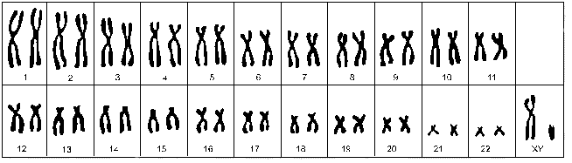

* The chromosomes appear as pairs of sister chromatids.
* There are 23 pairs (46 chromosomes) therefore this is human
* In this case the 23rdpair in this case are one long pair of chromatids (X-chromosome) and one very short (Y chromosome).
* This is a male human.
* There is no visible chromosomal abnormality.

**4.2.6 State that karyotyping is performed using cells collected by chorionic villus sampling or amniocentesis, for**

**pre-natal diagnosis of chromosome abnormalities.(1)**

State means to give a specific name, value or other brief answer without explanation or calculation.

* Pre-natal means before birth
* Diagnosis means to decide or find out what kind of disease or condition may exist.
* Pre-natal diagnosis are the methods used to determine if an unborn child is suffering from a disease or abnormal condition.
* karyotyping: If cells from the foetus can be obtained they can be cultured and then examined as in section 4.2.5 Karyotyping to determine if a genetic abnormality exists. e.g. Downs Syndrome
* Amniocentesis and chorionic villus sampling are the two main methods of obtaining tissue samples for pre-natal diagnosis.
* Both techniques take advantage of the fact that embryonic membranes, chorion, amnion and placenta are both derived form the embryo not the mother. The cells of these membranes have exactly the same genotype / genome (DNA) as the embryo.

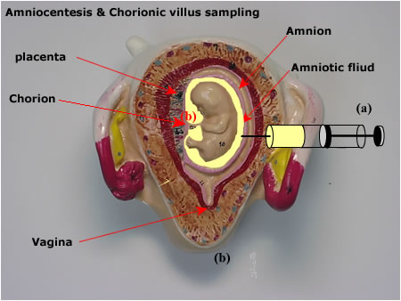**(a)**Amniocentesis involves the removal of amniotic fluid which surrounds the foetus.(after 14 weeks pregnancy)

The fluid is produced by the amnion membrane and contains cells from the foetus.

These cells are removed by inserting a needle through the abdominal wall, myometrium and into the amniotic fluid.

The is then centrifuged, cells are incubated and then subject to karyotyping (two weeks to develop).

The fluid (supernatant) can be used to test for neural tube disorders such as spina bifida.

(b) chorionic villus sampling involves the sampling of the chorion which is one of the extra-embryonic membranes (after 8 weeks pregnancy).

A catheter (tube) is inserted via the vagina and a sample is take of the chorion. The sample is extracted and cultured to produce cells for karyotyping(few days).

**TOKBIT: problems of knowledge**

There are a number of issues here that the student might like to consider.

1) Both sampling methods are risk and can cause the pregnancy to terminate (miscarriage). Therefore why take the risk?

Other indications of abnormalities: There are other test used to detect foetal abnormalities, try to find out what these might be.

Age of the mother: The older the mother the greater the risk of non-disjunction and the greater the chance of Downs Syndrome and other chromosomal abnormalities. Try to find additional information about the age related risks.

2) Minimizing the risks

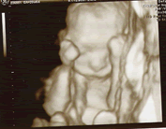This image of an unborn foetus was taken using a combination of ultra-sound and 3D imaging software.

Such images can be used to determine the position of the foetus within the uterus, thus minimizing the possibility of damage to the child from the tissue sampling.

3) Knowledge: These tests are not treatments they simply put people in the possession of information on which they can make 'informed decisions'.

**4.2.7 Analyze a human karyotype to determine gender and whether nondisjunction has occurred.(3)**

Analyze means to interpret data to reach conclusions.

* karyotyping can be carried out when:
* Chromosomes from the metaphase are available.
* Appropriate staining techniques are used to reveal characteristic banding patterns.
* Count the number of chromosomes.
* Size of the sister chromatids can be compared to find the homologous pairs
* Position of centromeres.
* Human Karyotyping exercise.
* The human karyotype has already been organised for you. Try to spot the abnormal condition and then try to identify its name and the symptoms of the condition.

